**Assignment-22.2:**

DATA SET DESCRIPTION

Column 1: Video id of 11 characters.

Column 2: up loader of the video

Column 3: Interval between day of establishment of Youtube and the date of uploading of the video.

Column 4: Category of the video.

Column 5: Length of the video

Column 6: Number of views for the video.

Column 7: Rating on the video.

Column 8: Number of ratings given for the video

Column 9: Number of comments done on the videos.

Column 10: Related video ids with the uploaded video.

DATA SET LINK: Youtube Data set

Find out what are the top 5 categories with maximum number of videos uploaded.

Driver Class:

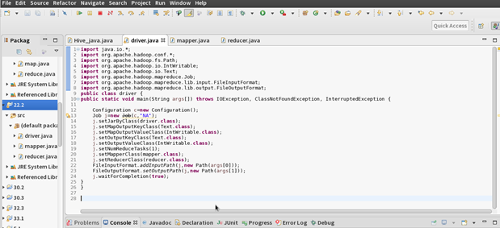

Mapper Class:

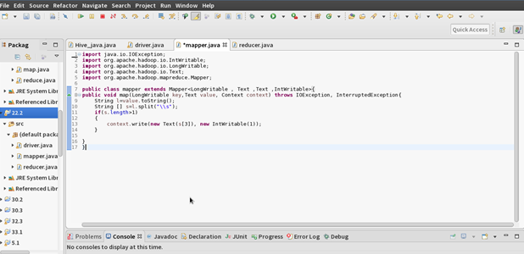

Reducer Class:

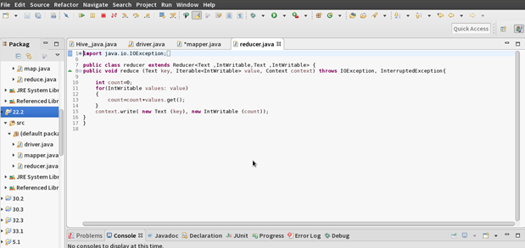

Running the Jar File:

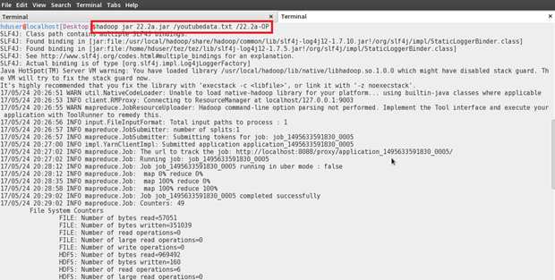

Output:

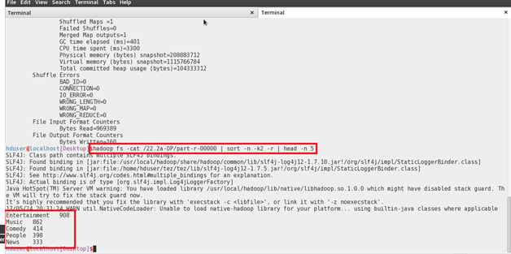

**PROBLEM STATEMENT 2** :

Find the top 10 rated videos in youtube.

Driver Class:

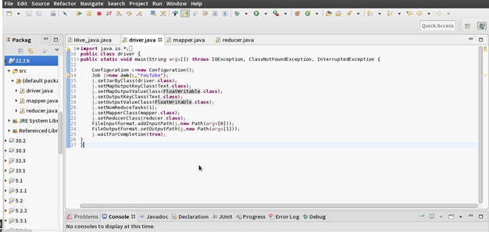

Mapper Class:

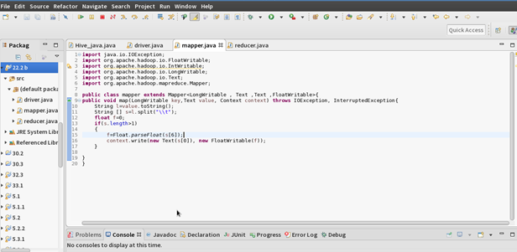

Reducer Class:

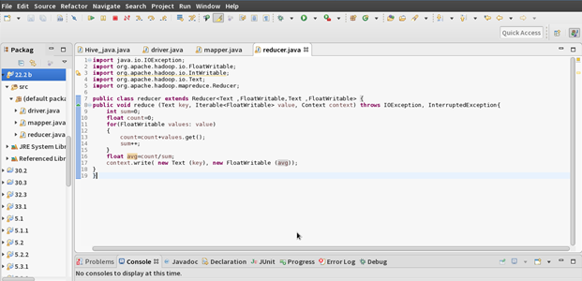

Running the Jar File:

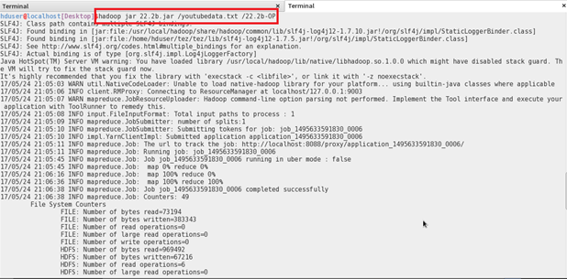

Output:

